Title
Firstname Lastname ¹, Firstname Lastname ² and Firstname Lastname ^{2,}*
¹ Affiliation 1;
² Affiliation 2;
* Correspondence: e-mail@e-mail.com; Tel.: (optional; include country code; if there are multiple corresponding authors, add author initials)
Abstract:
One page maximum, but not less than 200 words. For research articles, abstracts should give a pertinent overview of the work. We strongly encourage authors to use the following style of structured abstracts (after MDPI journal), but without headings: (1) Background: Place the question addressed in a broad context and highlight the purpose of the study; (2) Methods: briefly describe the main methods or treatments applied; (3) Results: summarize the article's main findings; (4) Conclusions: indicate the main conclusions or interpretations. The abstract should be an objective representation of the article and it must not contain results that are not presented and substantiated in the main text and should not exaggerate the main conclusions.
Keywords: keyword 1; keyword 2; keyword 3 (List three to ten pertinent keywords specific to the article yet reasonably common within the subject discipline.)

1. Introduction Bold, space 12pt bef., 3pt aft., 1.5 line
Insert your introduction here. First line by 0.25cm
The extended abstract should not exceed 4 pages.

2. Methodology
Do not forget to include your methodology. It is exceedingly important that all readers clearly understand your methodology. The methodology section frequently contains a series of numbered equations containing variables. Define all variables. Do not use numeric values, numeric examples or include results in this section. Do not repeat equations; refer to equations by equation number. List all assumptions. Identify the limitations of the methodology. Use as many sections and subsections as needed to organize the methodology.
2.1. Second level heading Bold, italic
This example should be used for any second-level headings. This is the template for the ICBM14 conference proceedings. Please use these formats to ensure that your article does not exceed the page limit. This is the template for the ICBM14 conference proceedings. Please use these formats to ensure that your article does not exceed the page limit. This is the template for the ICBM14 conference proceedings. Please use these formats to ensure that your article does not exceed the page limit. This is the template for the ICBM14 conference proceedings. Please use these formats to ensure that your article does not exceed the page limit.
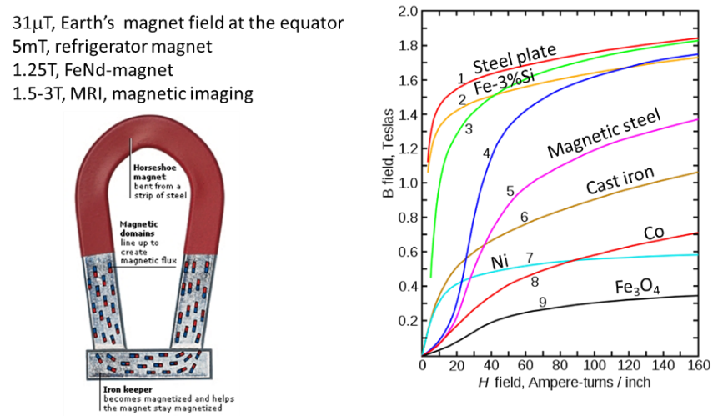
Figure 1. Figure caption here Garamond 10
2.2. Third level heading
This example should be used for any third-level headings. This is the template for the ICBM14 conference proceedings. Please use these formats to ensure that your article does not exceed the page limit. This is the template for the ICBM14 conference proceedings. Please use these formats to ensure that your article does not exceed the page limit. This is the template for the ICBM14 conference proceedings. Please use these formats to ensure that your article does not exceed the page limit. This is the template for the ICBM14 conference proceedings.
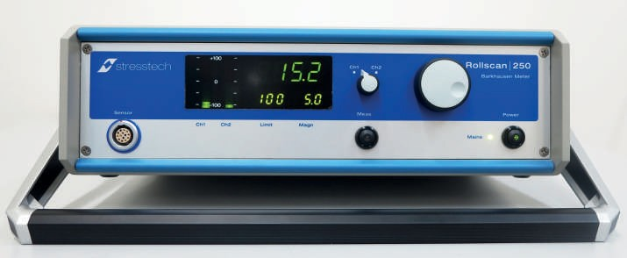
Figure 2. Figure caption here Garamond 10

3. Experiments
Please use these formats to ensure that your article does not exceed the page limit. This is the template for the ICBM14 conference proceedings.
Table 1 Table caption here Garamond 11
Law | Integral form of equation | Differential form of equation | Physical interpretation
Gauss’s law for $\vec{E}$ | $$∯_{S}{\vec{E}∙d\vec{A}=\frac{Q}{ε_{0}}}$$ | $$∇∙\vec{E}=\frac{ρ}{ε_{0}}$$ | Electric flux through a closed surface is proportional to the charge enclosed.
Faraday’s law | $$\oint{\vec{E}∙d\vec{s}=\frac{dΦ_{B}}{dt}}$$ | $$∇×\vec{E}=-\frac{∂\vec{B}}{∂t}$$ | Changing magnetic flux is associated with an electric field.
Gauss’s law for $\vec{B}$ | $$∯_{S}{\vec{B}∙d\vec{A}=0}$$ | $$∇∙\vec{B}=0$$ | The total magnetic flux though a closed surface is zero.
Ampere–Maxwell law | $$\oint{\vec{B}∙d\vec{s}=μ_{0}I+μ_{0}ε_{0}\frac{dΦ_{E}}{dt}}$$ | $$∇×\vec{B}=μ_{0}\vec{J}+μ_{0}ε_{0}\frac{∂\vec{E}}{∂t}$$ | Electric current and changing electric flux is associated with a magnetic field.

4. Results and discussion
Remember to include results. Apply the methodology to generate numeric results. If measured data are available, compare the numeric results to measured results. Comment on the agreement between theoretical and measured results.

5. Summary/Conclusion
The summary, conclusion and future work are all different and are all important. First, summarize the paper. The summary should be like the last section of the Introduction but should usually contain important numeric results. Next, state explicitly what the reader should conclude from the work. Describe how the work should be interpreted and why it is important. Do not assume that the reader will figure this out on his/her own. Finally, describe what steps you would take to improve the work.

References Bold, Garamond 10
All references must be cited, and vice versa. Examples:
- Fleisch D., A Student’s Guide to Maxwell’s Equations. Cambridge University Press, 2008. ISBN: 978-0521877619.
- Stefanita C.-G., From Bulk to Nano. The Many Sides of Magnetism. Verlag Berlin Heidelberg: Springer, 2008. ISBN: 9783540705475.
- Tomkowski, R.; Sorsa, A.; Santa-aho, S.; Lundin, P.; Vippola, M., Statistical Evaluation of Barkhausen Noise Testing (BNT) for Ground Samples. Sensors 2019, 19, 4716. https://doi.org/10.3390/s19214716
- Santa-aho S.; Hakanen M.; Sorsa A. et al., Case Depth Verification of Hardened Samples with Barkhausen Noise Sweeps, 2014. AIP Conf Proc 1581 33:1307–1314. DOI: 10.1063/1.4864972.

